Farmingdale Scarecrow Contest
Registration Form
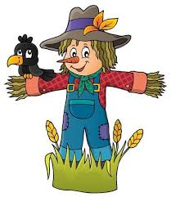
Open to all Farmingdale residents, No fee to enter!
All Scarecrows will be judged on: Creativity, Use of Materials, Originality & Visibility
Prizes awarded for 1st, 2nd & 3rd Place!!

Name: ____________________________________

Address: ___________________________________

Phone #: ___________________________________

Email: ___________________________________________________

- Grand Prize Winner plus up to 3 family members will ride in the 2022 Memorial Day Parade, be featured on our website, and win a $50.00 Gift Card
- Second Place Winner will win a $50.00 Gift Card
- Third Place Winner will win a $25.00 Gift Card
All winners will have a choice of: Breakfast Club, Bruno’s,Connie’s,
El Burro, Four Boy’s, Harvest, Tony’s, or Woody’s for their gift card.

Be part of the fun! Join other Farmingdale residents as they show their creativity!! All scarecrow’s must be up by Fri. Oct.16th. The winners will be announced on Sat.Oct.23rd on our website.
All Scarecrows must be made and displayed in good taste, or will be disqualified.
Sign up on our website: www.farmingdaleborough.org or fill out this flyer and drop it in the mailbox at borough hall: 11 Asbury Ave, Farmingdale
Good Luck & Have Fun!!!!

